**MPCA LAB WEEK-6**

**NAME : LAXMIKANT BHUJANG GURAV**

**SRN : PES1UG20CS658**

**ROLL NO.: 55**

**SECTION : K**

**DATE : 03-03-2022**

**PROGRAM 1 :** Write a program in ARM7TDMI-ISA to find the sum of all the digits in an 32 bit number.

**CODE:**

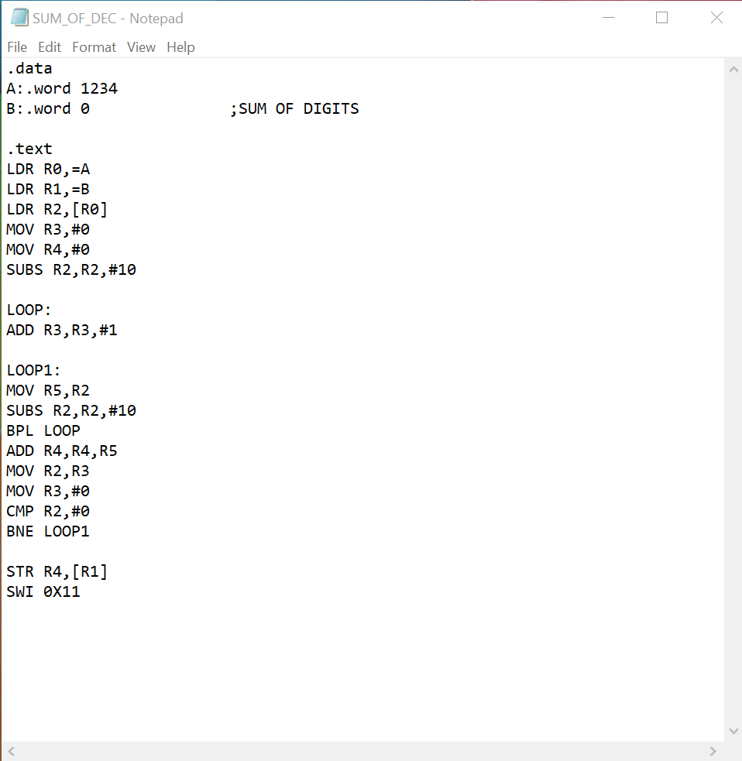

**OUTPUT:**

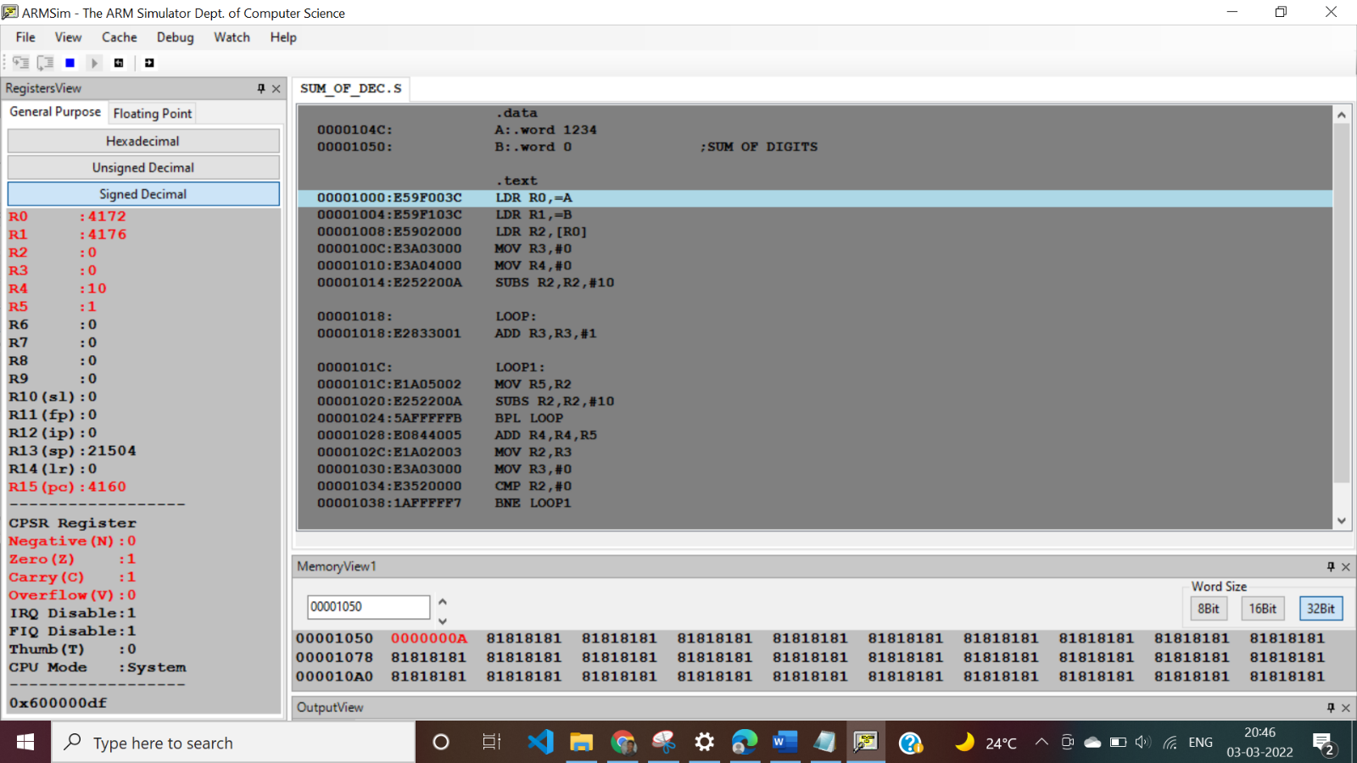

**PROGRAM 2 :** Write a program in ARM7TDMI-ISA to find the number of occurrences of a given character in a string.

**CODE:**

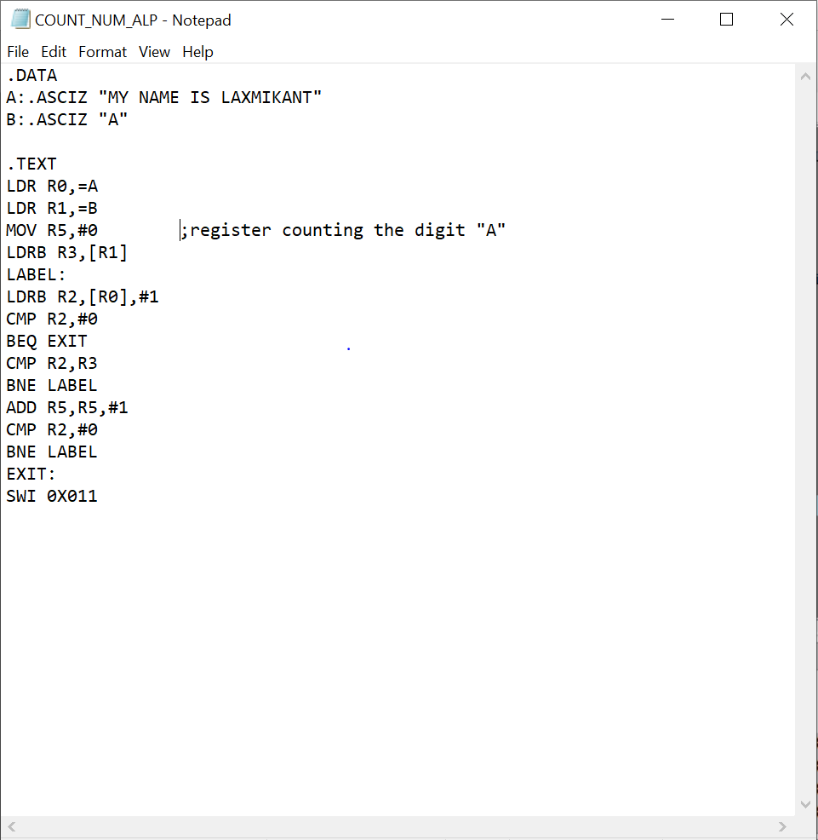

**OUTPUT:**

